PIZZA SALES (2015) SQL QUERIES
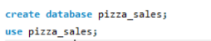
Total records:
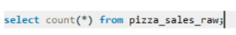
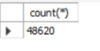
- Total revenue generated from all pizza sales.
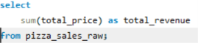
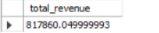

- unique orders were placed.
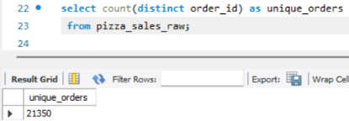

- total number of pizzas sold.
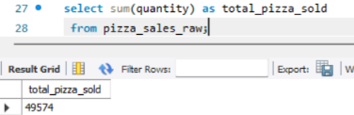

- average order value.
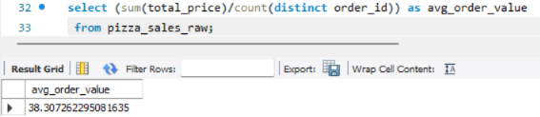
- average number of pizzas sold per order.
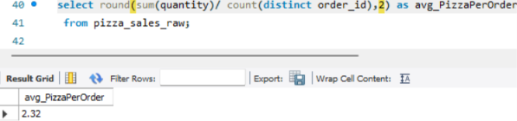

- total revenue generated by each pizza category, from highest to lowest.
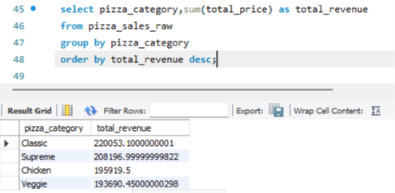

- total revenue generated by each pizza size, from highest to lowest.
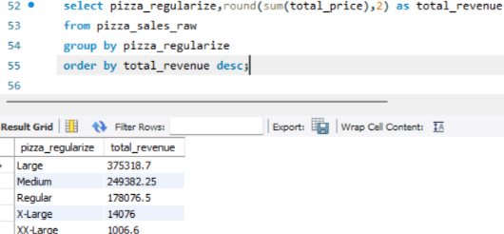

- total number of pizzas sold for each pizza category, from highest to lowest.
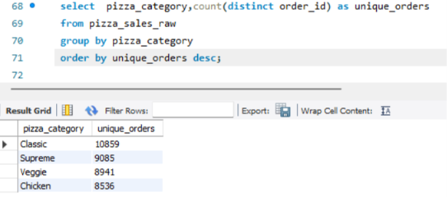

- number of unique orders placed on each date, ordered chronologically.
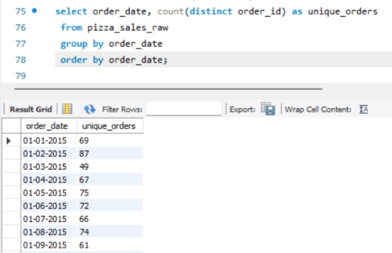

- total revenue generated in each month, ordered from January to December.
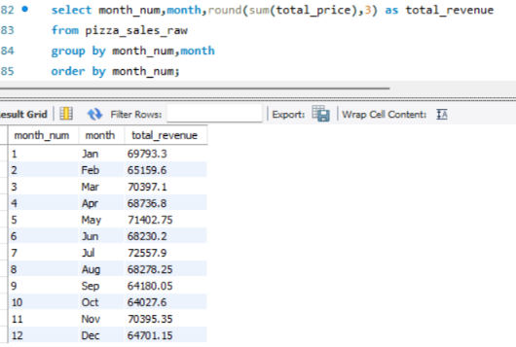

- total number of unique orders for each day of the week, ordered from Monday to Sunday.
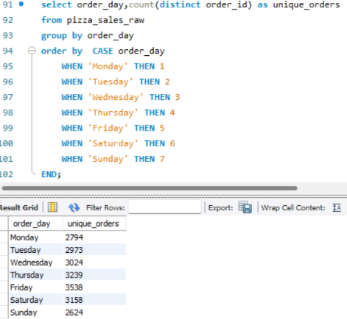

- number of unique orders placed during each hour of the day, from earliest to latest.
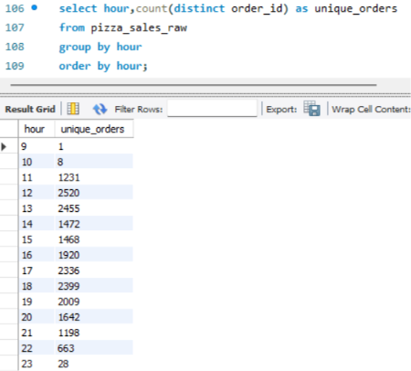

- top 5 pizzas with the highest total quantity sold.
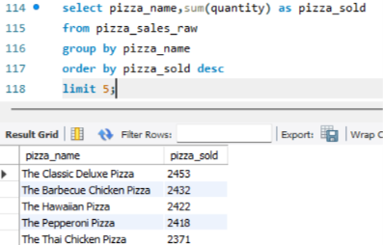

- bottom 5 pizzas with the lowest total quantity sold.
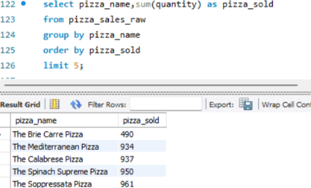

- top 5 pizzas generating the highest total revenue.
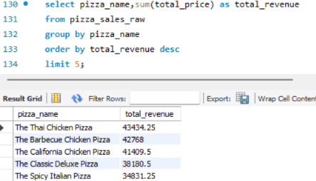

- bottom 5 pizzas based on total revenue.
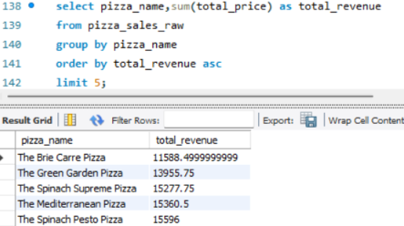

- percentage of total revenue does each pizza category contribute.
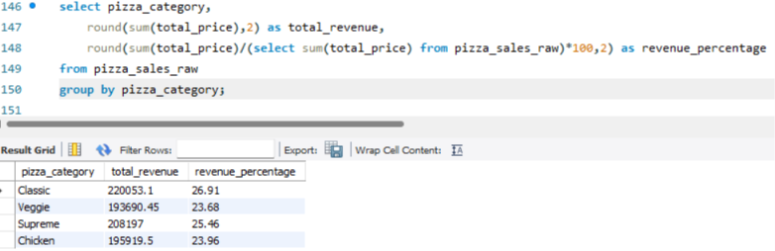

- percentage of the total pizzas sold comes from each pizza category.
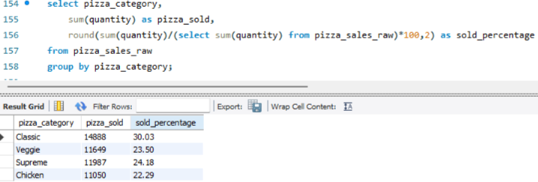

- average unit price of pizzas in each category, from highest to lowest average price.
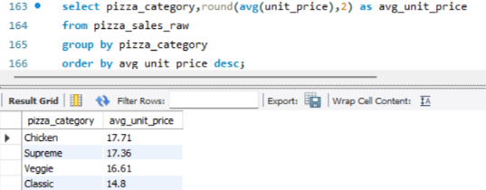

- Which single pizza generated the highest total revenue, and how much revenue did it generate?
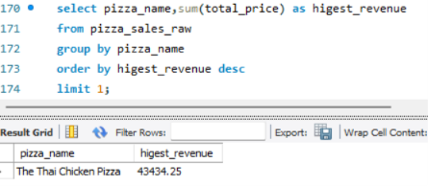

- Which single pizza had the highest total quantity sold, and how many pizzas were sold?
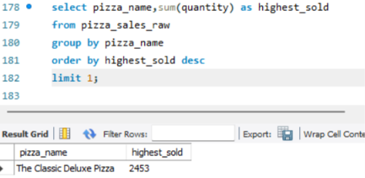

- the highest-revenue month in 2015.
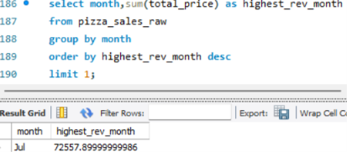
- lowest revenue month in 2015.
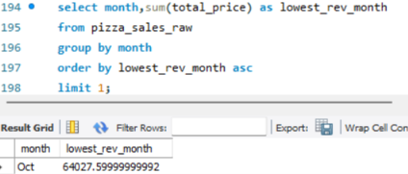

- hour of the day which has the highest number of unique orders.
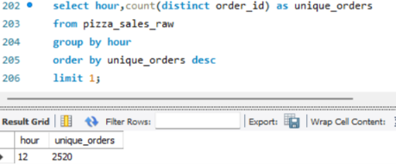

- day of the week had the highest number of unique orders.
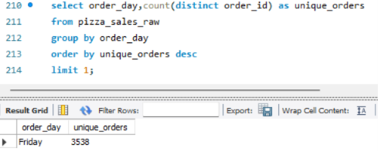

- average revenue generated per pizza sold.
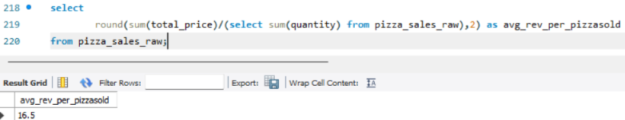

- the number of different pizza types available in each pizza category.
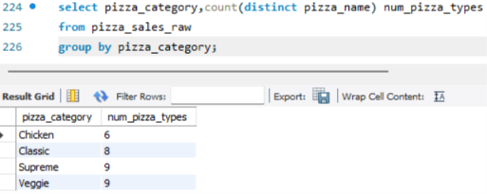

- the average number of pizzas in each order, but this time calculated it at the order level.
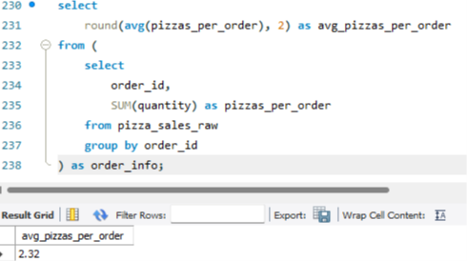

- the total revenue for each pizza, and ranked the pizzas from highest to lowest revenue.
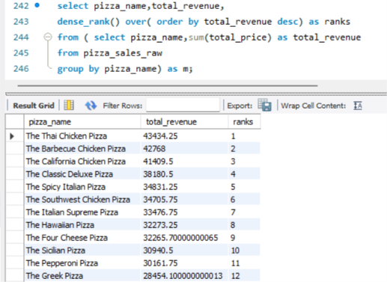
- Within each pizza category, ranked pizzas by total revenue from highest to lowest.
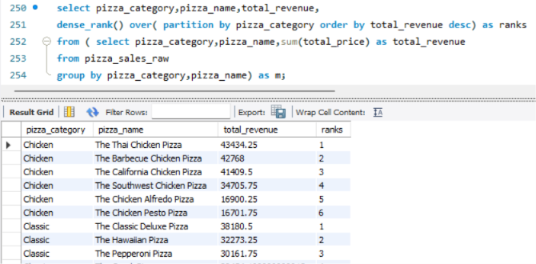

- Return only the top 2 highest-revenue pizzas from each pizza category.
- Using Sub-query:
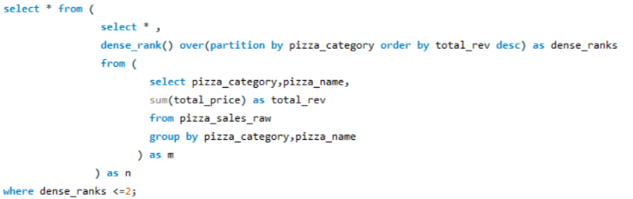
- Using CTE:
